INSURANCE AGENT PORTAL
IAP-0001

Requirements Specification

Record of Release

Version No. | Modified By | Reviewed By | Authorized By | Release Date | Modifications Done
001 | Varun Khadayate; Kartik Padave; Shreyash Agarawal | Simran Kumari | Jitesh Mishra | 19-07-2020

Table of Contents
1.0 Introduction 3
1.1 Overview of the Requirement Specifications Document 3
1.2 Scope of the Project 3
2.0 Application Environment 4
2.1 Business Context 4
2.2 Volumetric Data 4
2.3 Constraints 5
3.0 Requirements Specifications 5
3.1 Details of requirements gathering process 5
3.2 References to Customer’s documents 6
3.3 Functional Requirements 6
3.4 Operating Environment Requirements 8
3.5 External interface requirements 9
3.6 Other requirements 10
4.0 Prototype 11
5.0 Acceptance 11
5.1 Acceptance Criteria 11
6.0 Abbreviations / Bibliography 12

Introduction

Overview of the Requirement Specifications Document

Purpose of the Document

This document provides a detailed view of requirements of software- Insurance Agent Portal. IAP is online insurance system for the agent which is specially designed to minimize work of agent at the same time increasing the productivity and revenue of the agent. The document covers every aspect of requirements of the project and clearly explains all the requirements of software to the reader.

Current System
Currently developed software is the first IAP software created for the customer.

Limitations of the Current System
No limitation of the application is yet identified.

Scope of the Project
This system helps client to manage their customers effectively and efficiently. This Software gives customer an online presence. The software saves agents time to interact with customer for menial tasks by doing it by itself.
This software helps client to give its customers a luxurious experience by minimizing their work.

Application Environment

Business Context

The developed software helps client’s business to enter a new paradigm of growth and helps it in achieving new milestones in the following ways:

- It opens numerous opportunities for revenue generation.
- Software helps customer to get acquainted with the agent.
- To connect and serve customer easier and faster than before.
- To build stronger relationship with customer.

User Profiles
Agent:
Insurance agent will use the software to receive information about the appointments made with customer. Agent will get data of payments done by customers for insurances.

Customer:
Customer gets to know the agent in a better way. They can share payment details directly with the agent for buying insurances for them. He/ She gets to know about all the services provided by the agent. Customer can also make an appointment with agent using the developed software.

Marketing Representative:
The software would also be used by marketing professionals to drive traffic to the website for better usage of software.

Volumetric Data
Data of I.P address through which website was visited, advertisements shown on the website, data entered by the user in forms, payment details and in chat-bot are stored as per the guidelines mentioned in National Cyber Security Act of 2013 and Information Technology Act (2000) as per geographical location.
Planned maximum volume of data to be stored is 500TB.
Data Archival is only done for I.P. addresses and Payment details

Constraints

Environment Imposed
User should at least have 2G net connection and a web browser. Except this there are no environment constrains on the software.

Statutory Requirements
No statutory requirements could be found on the discussion with the legal team. The requirements were under the conditions of National Cyber Security Act of 2013 and Information Technology Act (2000).

Memory Constraints
Maximum volume of data to be stored is 500TB.

Performance
There are no performance constraints on the software except:
The performance of site is 88 on the scale of 100 as per the Google Insights.
The internet speed of 2G is required to maintain the performance level of software above 40 on 100 scale of Google Insights.

Requirements Specifications

Details of requirements gathering process

Requirement gathering process was done by interviewing customer. Survey of sites like ‘www.amarbima.com’ was done as mentioned by the client in the initial document. In the requirement gathering process we had recorded all the requirements from the client during the practical session using interview process of information gathering.

On interviewing customer we became fully aware of customer requirements. After consulting with the team on the received requirements, one member from our team had a phone call with the client to rectify some doubts related to the software. All the requirements discussed were documented on the call with customer.

Insurance agent Chandravadan Prajapati was contacted for requirement gathering process.
Refer document: List Of Requirements

References to Customer’s documents
- Notepad: Insurance Agent Portal

Functional Requirements

Requirement Id | Requirement Category | Requirement Type | Requirement Importance | Priority | Hierarchy | Ref. | Status
Req-01 | Technical | Functional | High | High | After Req-02 | Interview Findings | Open
Requirement description | EMI calculator, it calculates EMI of Insurance based on the inputs given by the user.
Scope | This will give an Idea about EMI of Insurance
Method of Validation | Software calculation was crosschecked by human calculation via calculator

Requirement Id | Requirement Category | Requirement Type | Requirement Importance | Priority | Hierarchy | Ref. | Status
Req-02 | Technical | Functional | High | High | Before Req-01 | Interview Findings | Open
Requirement description | Chat bot to help customers visiting the website
Scope | Chat –bot will help customers about their queries related to navigation through site.
Method of Validation | Manual testing was done to verify this feature.

Requirement Id | Requirement Category | Requirement Type | Requirement Importance | Priority | Hierarchy | Ref. | Status
Req-03 | Technical | Functional | Medium | High | Same as Req-01 | Interview Findings | Open
Requirement description | Feature to book an appointment with the agent.
Scope | Customer will use this feature to set an appointment with the agent. This feature is located In contact us screen.
Method of Validation | Manual testing was done to verify this feature.

Requirement Id | Requirement Category | Requirement Type | Requirement Importance | Priority | Hierarchy | Ref. | Status
Req-04 | Technical | Interface | Low | Low | Same as Req-01 | Interview Findings | Open
Requirement description | Payment Details Screen
Scope | Through this screen customers can give information about the payments made by them to the agent directly.
Method of Validation | Manual testing was done to verify this feature.

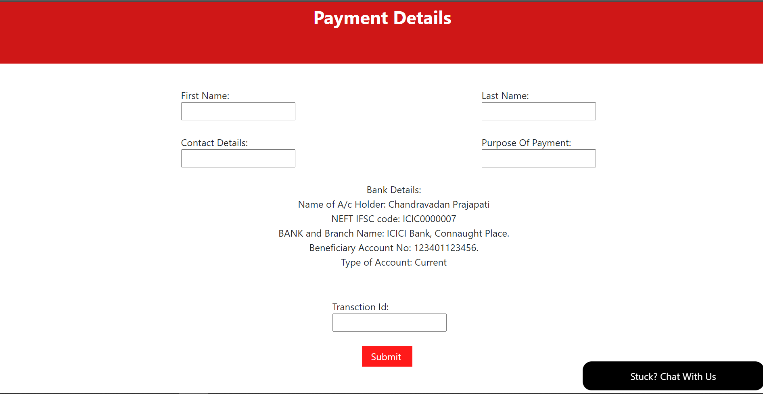

Requirement Id | Requirement Category | Requirement Type | Requirement Importance | Priority | Hierarchy | Ref. | Status
Req-05 | Non-Technical | Functional | Trivial | Low | Same as Req-01 | Interview Findings | Open
Requirement description | Our Services Screen
Scope | This feature will give customer idea about services offered by the agent.
Method of Validation | Manual testing was done to verify this feature.

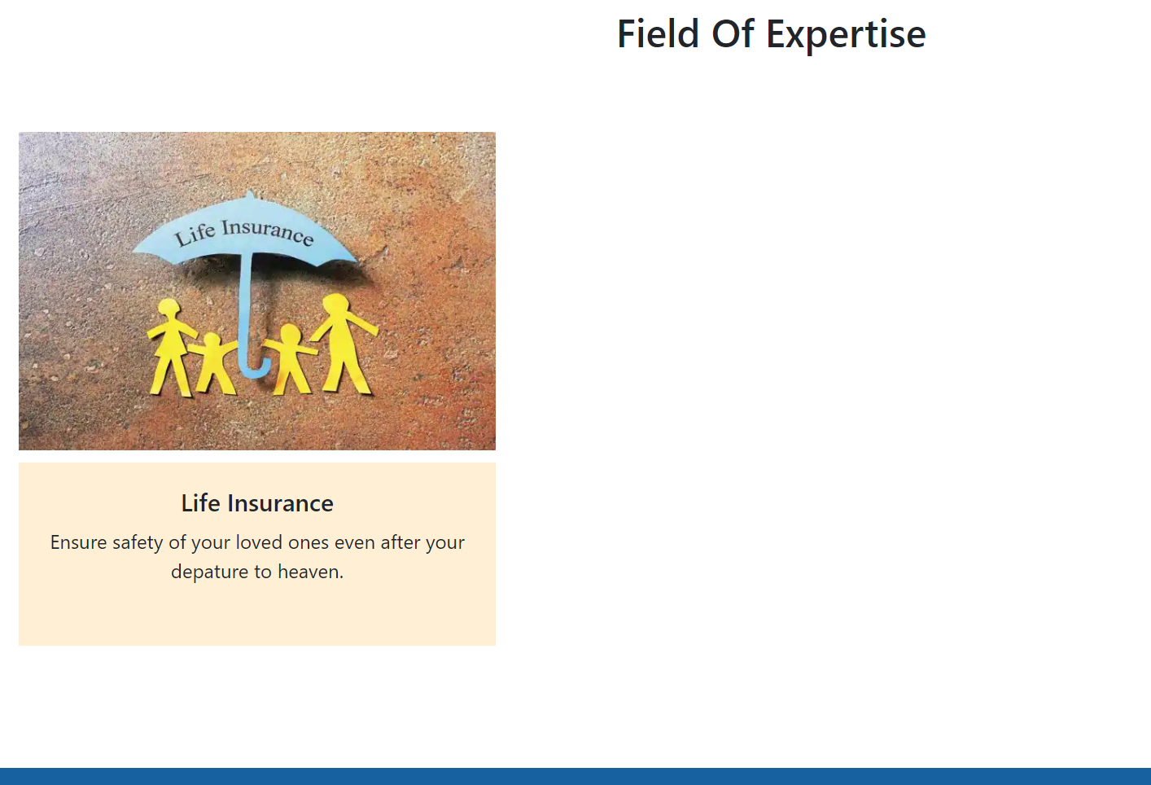

Requirement Id | Requirement Category | Requirement Type | Requirement Importance | Priority | Hierarchy | Ref. | Status
Req-06 | Non-Technical | Interface | Medium | Medium | Same as Req-01 | Interview Findings | Open
Requirement description | 3 Rolling images on home screen
Scope | This feature will be the first thing after nav-bar on home screen increasing the appearance of the site
Method of Validation | Manual testing was done to verify this feature.

Requirement Id | Requirement Category | Requirement Type | Requirement Importance | Priority | Hierarchy | Ref. | Status
Req-07 | Technical | Functional | Low | Low | Same as Req-01 | Interview Findings | Open
Requirement description | News description.
Scope | This feature is used to give a glimpse about insurance world.
Method of Validation | Manual testing was done to verify this feature.

Operating Environment Requirements

Hardware
PC

Software
Internet Browser

Network
Internet connection: Minimum 2G Internet connection and preferred good Wi-Fi bandwidth.

Communication
Outsourced to google forms for appointment
Payments details are transferred to database

External interface requirements

User Interface
User Interface requirements on the basis of:
- GUI/Character-based: Navigation Bar, Making an appointment and payment
- Customer supplied screen / menu standards: Home, Our Services, About Us, and Payment, Contact us
- On-line help: Chat-bot

Hardware Interface
Not required for developed software.

Software Interface
Google Forms
On clicking make an appointment button the user is taken to google form
On clicking submit button on payment page the information of the payee is stored in the database.
On clicking buttons on navigation bar user is taken to different screens.

Database Requirements
The database requirements of software are classified on:
- Restrictions on size of database objects: Confined to maximum limit of 500TB.
- On-line backup: Null
- Archiving: Data Arching is only done for I.P. addresses and Payment details.
- DBMS environment: Centralized database is used

Operational Requirements
These requirements refer to the operational aspects of the system and can be of the following nature:
- Multi site operation: Maximum 5 Multi site operation
- Multi user operation: Maximum 1 Crore Multi user operation
- On line/batch: On line Application

Performance Requirements
Specific performance requirements in terms of
- Response time for transition of pages: 1.5s with optimal internet connection
- Interfaces to external systems: Slight performance may be affected depending on user hardware

Other requirements

Security
There are no security requirements for the software since it doesn’t contains any sensitive information.

Reliability
These are the requirements of the following nature:
- Graceful exit on abnormal inputs / conditions: Calculated range of 10mb is provided any abnormal inputs above that would be not accepted and customer would be sent back to home page.
- Causing minimal damage to the environment in case of abnormal conditions: Adequate backup has been set in pace in case of natural calamities and other factors outside our control.
- Ease of recovery: 15 Days recovery time of any data deleted from the user end.

Maintainability
The requirements here would specify the following:
- Use of development standards: Angular 10 was used to develop the software. Project was done by using incremental model.
- Availability of documentation: RTT, Requirement Gathering Checklist, Requirement Specification Review Checklist. Attached with these documents.

- Documentation Standards: Peer Review Documentation Method.

Availability
Software is available for all 24 hours. Except during maintenance breaks.

Scalability
System is scalable to 5 multiple virtual instances of the website.
System is scalable to handle 1 crore maximum users at a time.

Portability
There is no portability issue with the software it works on Windows, Linux and Mac

Data Migration
There are no Specific requirements for data migration server is self-owned.

Installation
No installation to be carried out for the use of application.

User Training
Software is simple and self-explanatory no user training required.

User Manual and Help
Software is simple and self-explanatory no user training required.
An online chat-bot is present for help.

Automated and Manual features
Loan calculator is the only automated feature present in the software.
Features of making an appointment and submitting payment details are manual.

Features Not Required
No such feature was found.

Prototype
Prototype doesn’t exist for this software.

Acceptance

Acceptance Criteria
- Software runs on every available pc, environment is unaffected by change in OS.
- Minimum 2G network connection is required for the software to run properly.
- Software follows the legal guidelines laid down by the government.
- Multi-site and multi user testing has been done to ensure working of the software.
- Maximum of 500Tb Volume of data is allocated to store data.
- Software is available 24x7, expect maintenance time.
- User profile:
  - Insurance Agent
  - Customer
  - Marketing Agent
- All the documentation has been done using peer review method.

Abbreviations / Bibliography
Abbreviations | Meaning
MTBF | Mean Time Between Failure
RDBMS | Relational Database Management System
IAP | Insurance Agent Portal
SRS | Software Requirement Specification
GUI | Graphical User Interface

